TECHNICAL PROJECT REPORT

# Title of Invention / Project:

# THE BUTTON GAME

# Team Members / Inventors:

|  |  |  |  |  |  |
| --- | --- | --- | --- | --- | --- |
| **S.**  **No.** | **Name** | **Department** | **Designation** | **Mobile** | **E-Mail** |
| **1.** | **AMIT YADAV** | **AI & ML-1** | **Student** | **8874423638** | **sy4306122@gmail.com** |
| **2.** | **GURSIMARPAL SINGH** | **AI & ML-1** | **Student** | **7340840032** | **gursimarpal7@gmail.com** |
| **3.** | **YASH AGRAWAL** | **AI & ML-1** | **Student** | **7379883733** | **agarwalyash1410@gmail.com** |
| **4.** | **Khushal Thakur** | **ECE** | **Mentor** | **9646030764** | [**khushal.thakur@cumail.in**](mailto:khushal.thakur@cumail.in) |
| **5.** | **Anshul Sharma** | **ECE** | **Mentor** | **9478697475** | [**anshulsharma.ece@cumail.in**](mailto:anshulsharma.ece@cumail.in) |
| **6.** | **Kiran Jot Singh** | **ECE** | **Mentor** | **9463909689** | [**kiranjotsingh.ece@cumal.in**](mailto:kiranjotsingh.ece@cumal.in) |
| **7.** | **Divneet Singh**  **Kapoor** | **ECE** | **Mentor** | **9878422653** | [**divneet.ece@cumail.in**](mailto:divneet.ece@cumail.in) |

Section – 1 (IPR Related)

# Brief Abstract (500 words):

It is a simple button game which is played by two players at a time. The concept is very simple, whosoever presses the button 21 times first will win the game. It is an interesting game which is correlated to arm wrestling. Just like whosoever applies more pressure wins the game in this also whosoever rapidly clicks 21 time will win the game.

We have connected two arduino with two buttons which records the number of clicks by each player. The main arduino is connected with lcd. The arduino which has first 21 clicks will send signal to the main arduino which orders to the lcd to display the winner on the screen. To make it more interesting we have connected to leds to each arduino. Like in every click one led glows and every fifth click all leds off and one main led glows and after 21 clicks one main led start glowing and other leds start blinking. This seeks the attention of the player to play it and concept has been made more interesting by this led concept.

There can be still many modifications which can be done like the design of the game is too obsolete. It can be modified. Despite the design led concept has been used to make the game more attracting. This concept can also be replace or can be modified by a better one to make it more attracting.

# Existing state-of-the-art and Drawbacks in existing state-of-the-art

|  |  |  |
| --- | --- | --- |
| **S. No.** | **Existing state of art** | **Drawbacks in existing state of art** |
| 1 | **CA2484568A1** | Size of box is to large and heavy |
| 2 | **JPH06315544A** | Mechanical hand is tough to hold tightly which harm you. |

# Novel/Additional modifications that you can propose to improve upon drawbacks

1. Structure of device is of old type model.
2. It has number of complexcity in it’s circuit work.

# Advantages

1. It is a simple game which tests the speed of an individual.
2. It also help in relaxing mind and for refreshment.
3. Programming concept has touched another level.

# Block Diagram

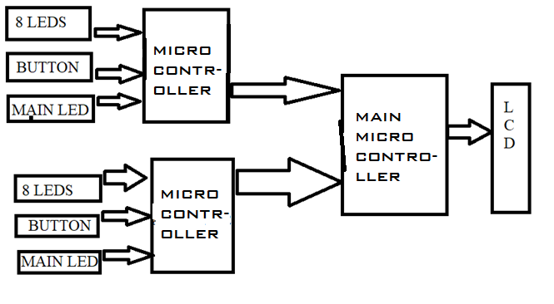

Section – 2 (Real Project)

# Material:

|  |  |  |  |  |
| --- | --- | --- | --- | --- |
| S .No | MATERIAL | NO OF QUANTITY | PRICE | TOTAL |
| 1. | ARDIUNO | 3 | 320 | 960 |
| 2. | LCD(16*2) | 1 | 180 | 180 |
| 3. | PCB | 2 | 20 | 40 |
| 4. | SWITCH(ON/OFF) | 3 | 5 | 15 |
| 5. | SWITCH | 2 | 5 | 10 |
| 6. | BATTERY | 3 | 15 | 45 |
| 7. | BOX | 1 | 150 | 150 |
| 8. | WIRE | 2m | 10 | 20 |
| **9.** | **TOTAL** | **16** |  | **1420** |

# Circuit Diagram:

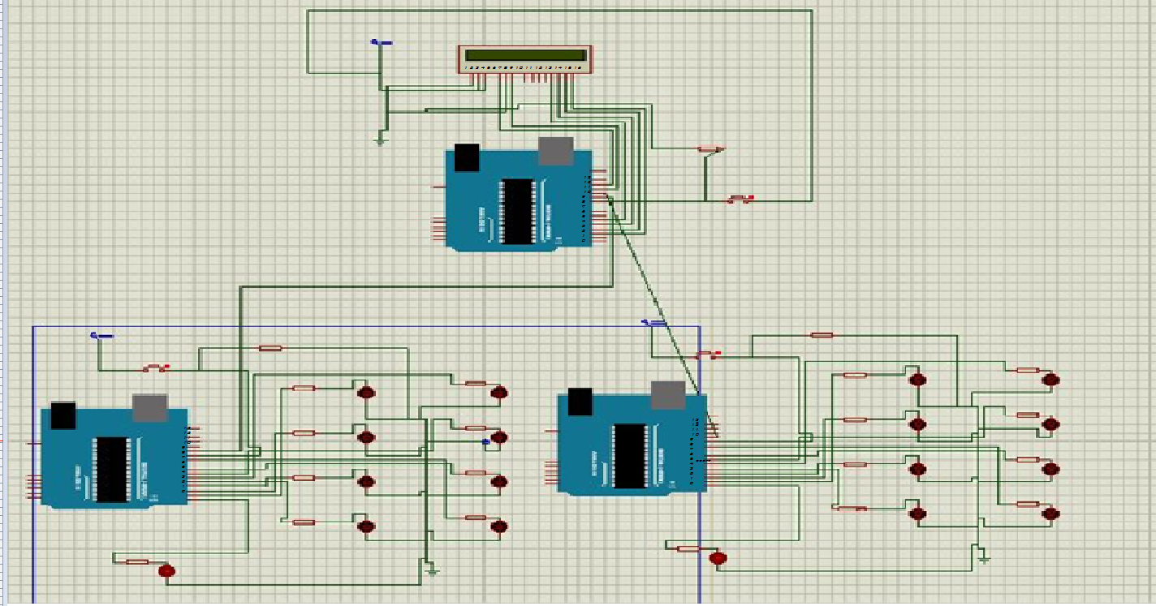

# Steps of Circuit Completion

1. CONNECTED 8 LEDS TO ONE ARDUINO

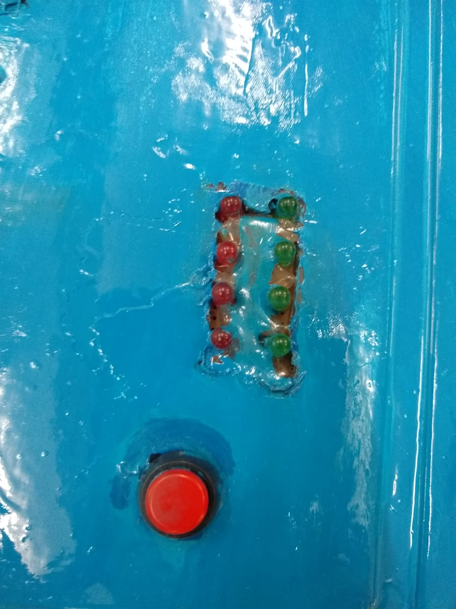

1. CONNECTED A SWITCH AND THE MAIN LED WITH IT

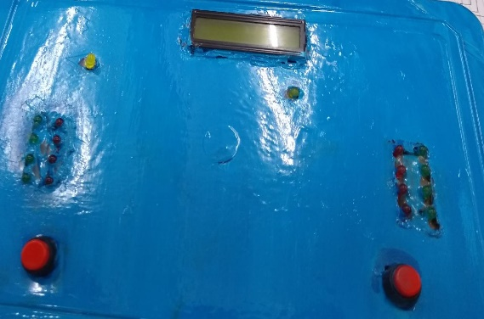

1. CONNECTED A BATTERY WITH IT

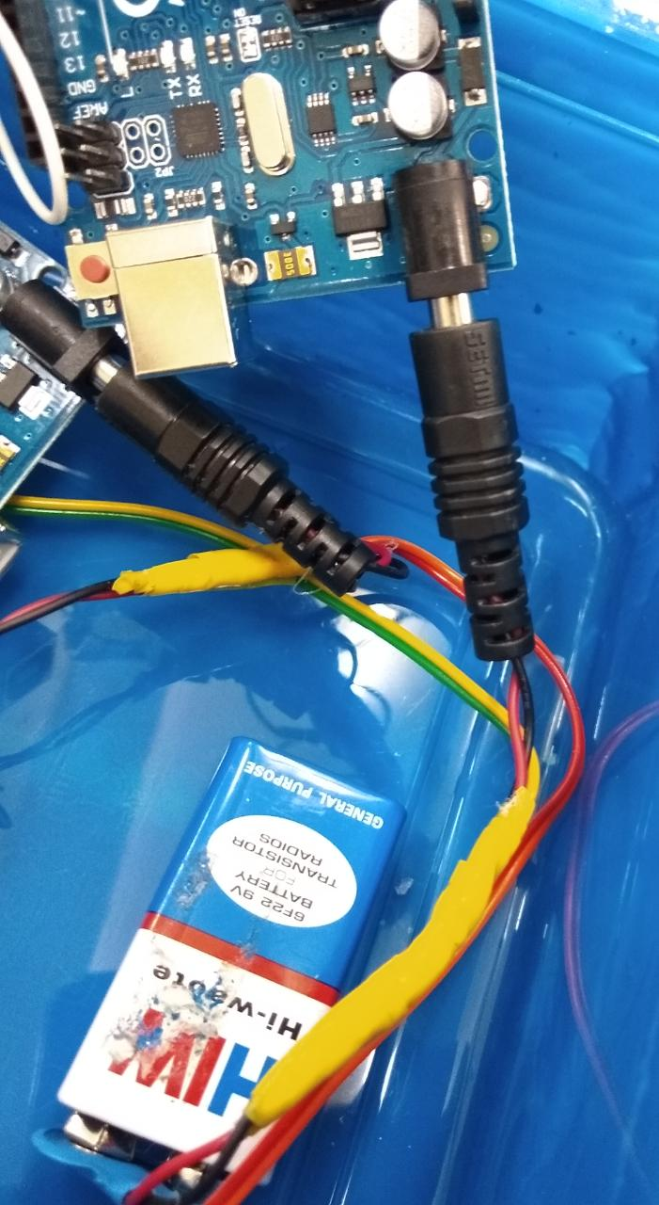

1. SIMILARLY DESIGNED THE SECOND ARDUINO
2. THE CONNECTED THE MAIN ARDUINO WITH A LCD DISPLAY

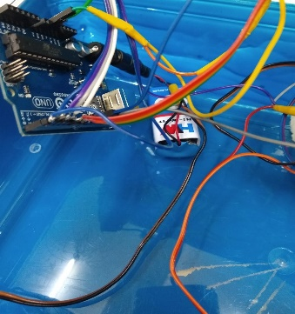

1. THE CONNECTED BOTH THE SECONDARY ARDUINO WITH THE MAIN ARDUINO WITH DIFFERSENT PINS.

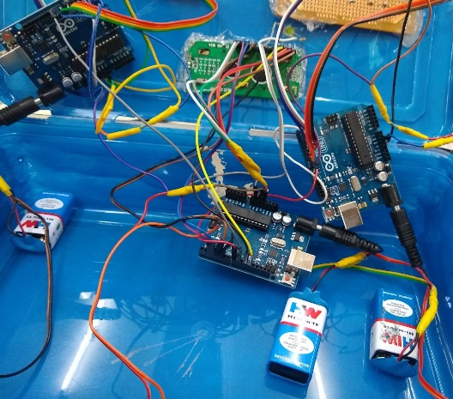

# Program

https://github.com/AMITYADAV88744/BEEE-PROJECT-FILE/blob/master/PROGRAM